**Exp No: 5**

**Date:**

**DESIGN A DESK CALCULATOR USING LEX TOOL**

**AIM:**

To check whether the arithmetic expression using lex and yacc tool.

**ALGORITHM:**

* Using the flex tool, create lex and yacc files.
* In the C include section define the header files required.
* In the rules section define the REGEX expressions along with proper definitions.
* In the user defined section define yywrap() function.
* Declare the yacc file inside it in the C definitions section declare the header files required along with an integer variable valid with value assigned as 1.
* In the Yacc declarations declare the format token num id op.
* In the grammar rules section if the starting string is followed by assigning operator or identifier or number or operator followed by a number or open parenthesis followed by an identifier. The x could be an operator followed by an identifier or operator or no operator then declare that as valid expressions by making the valid stay in 1 itself.
* In the user definition section if the valid is 0 print as Invalid expression in yyerror() and define the main function.

**LEX AND YACC WORKING:**

Parser generator:

* Takes a specification for a context-free grammar.
* Produces code for a parser.

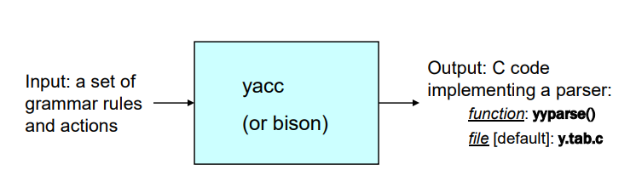

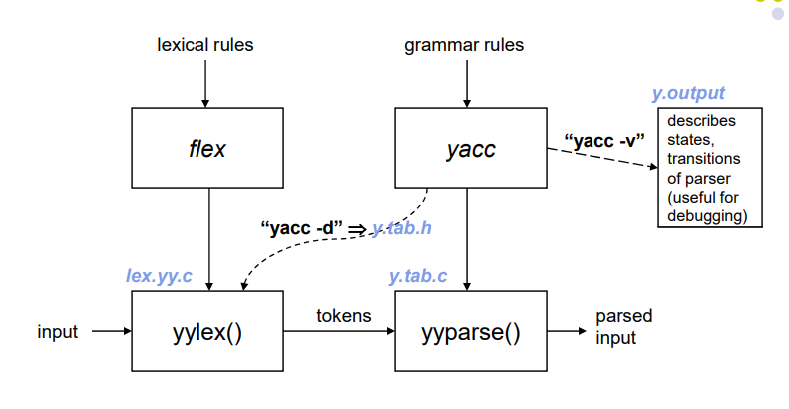

**PROGRAM:**

**cdlab5.l:**

%{

#include "y.tab.h"

%}

%%

[a-zA-Z_][a-zA-Z_0-9]* return id;

[0-9]+(\.[0-9]*)? return num;

[+/*] return op;

. return yytext[0];

\n return 0;

%%

int yywrap(){

return 1;

}

**cdlab5.y:**

%{

#include<stdio.h>

int yylex());

int yyerror();

int valid=1;

%}

%token num id op

%%

start : id '=' s ';'

s : id x

| num x

| '-' num x

| '(' s ')' x

;

x : op s

| '-' s

|

;

%%

int yyerror(){

valid=0;

printf("\nInvalid expression!\n");

return 0;

}

int main(){

printf("\nEnter the expression:\n");

yyparse();

if(valid){

printf("\nValid expression!\n");

}}

**OUTPUT:**

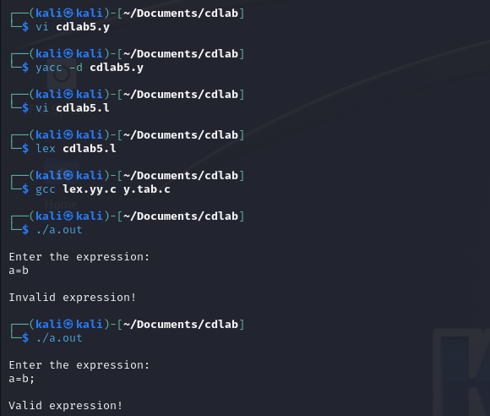

**RESULT:**

Thus, a program to check whether the arithmetic expression using lex and yacc tool is implemented.